SECTION EB

GENERAL OVERHAUL NOTES

CONTENTS

Chapter

General Notes.. .. .. .. .. .. .. .. .. 1

Cleaning .. .. .. .. .. .. .. .. .. 2

'AEROQUIP' Flexible Hose Connections .. .. .. .. 3

'LOCTITE' Locking and Sealing Compounds .. .. .. .. 4

Liquid Nitrogen - SAFETY PRECAUTIONS 5

Exhaust Thermocouple Cable .. .. .. .. .. .. 6

Viton. 'O' Rings .. .. .. .. .. .. .. .. 7

GENERAL OVERHAUL NOTES

1. The following notes are additional and are intended to assist servicing and maintenance operations described in this manual.

Health and Safety

1. U.K. standards for health and safety are covered by the Noise at Work Regulations 1989, the COSHH Regulations 1988, the HEALTH AND SAFETY AT WORK ACT, 1974 and by the FACTORIES ACT. For other countries the appropriate national standards must be observed.

Dismantling

1. For details of dismantling, inspection and assembly of individual components, refer to the appropriate section (see Index).

Lifting

1. When lifting heavier engine components, it is essential that the slings, strops, eyebolts and shackles used have a current test certificate for a SAFE WORKING LOAD well above the weight of the item to be lifted. Machined surfaces are to be protected from contact with the lifting equipment to prevent costly damage. Safety precautions are to be observed regarding suspended loads etc.

Protection of Dismantled Engine Parts against Corrosion

1. Where engines have been dismantled for inspection, ferrous parts must be protected against rusting. Care must also be exercised in handling parts with highly finished surfaces eg. bearing surfaces, since these surfaces can be corroded by fingerprints, especially in countries with a humid atmosphere.
2. After cleaning, parts should be protected by dipping or spraying with clean engine oil, or preferably with a de-watering fluid such as SHELL ENSIS FLUID 252 (one week protection) or 254 for longer periods. When using a de-watering fluid, parts should be cleaned in a solvent to remove all grease or oil, and fluid applied by dipping or spraying. The advantage of using a de-watering fluid is that it will remove moisture.
3. Where a cooling system or cooling system parts have been flushed through with SHELL ENSIS FLUID and then sealed, there is a possibility that a flammable vapour will remain. Before ANY installation work is begun, particularly where welding may be involved, treated areas should be flushed through with water containing a detergent such as ’TEEPOL MIXTURE’ or 'LISSAPOL N' in the ratio 1 part detergent to 200 parts of water. DO NOT exceed these proportions as a more concentrated mix may cause foaming.
4. Surface application of SHELL ENSIS FLUID forms an almost dry deposit which can be washed off with clean white spirit or similar solvent.
5. When the engine is rebuilt, parts should be degreased, re-oiled and fitted. Protect all openings against the entry of dirt etc.

Markings

1. Certain engine parts are marked for matching and timing purposes, others are marked according to their individual engine position; all such marks must be correctly matched when re-assembling components. All new parts, if not marked, must be marked by etching before fitting.

Covers and housings

1. Always use jacking screws to remove covers and housings where tapped holes are provided for this purpose. When replacing a spigotted cover or housing, ensure that the spigot is not burred or damaged in any way. Wipe mating faces perfectly clean.

Shims

1. When dismantling, note number and/or thickness of shims removed and then put them in a safe place for re-use provided they are not torn or crumpled. When assembling wipe all shims clean.

Oil Seals

1. A housing type seal (one that is pressed into position) which has been removed, should not normally be used again. If it is necessary to re-use a seal, make sure that the seal housing is not distorted. For all types of oil seal ensure that the lip of the seal and the shaft on which it bears are not damaged or worn.

Bushes

1. Never use a bush which has been removed from a housing in which it was a press fit. When inserting a new bush use a press wherever possible, or failing this a hardwood or soft metal drift. Bushes of the wrapped type (split bushes), must be fitted using a mandrel of the correct diameter to avoid distortion as due to the thickness of bearing material this type of bush cannot be reamed or broached after fitting.

Ball Bearings

1. Examine all bearing carefully for excessive play, broken cages, cracked balls, or blueing due to overheating.
2. Use a press to insert bearings which are an interference fit in their housings. If a press is not available, use a hardwood or soft metal drift. Pressure should be exerted on the outer race only.
3. If fitting a bearing directly on to a shaft, apply pressure to the inner race only.

Gaskets and Joints

1. Use new gaskets, joints and 'O' rings throughout. Gaskets and joints must be fitted dry, but a smear of soft soap or petroleum jelly may be necessary when fitting 'O' rings.

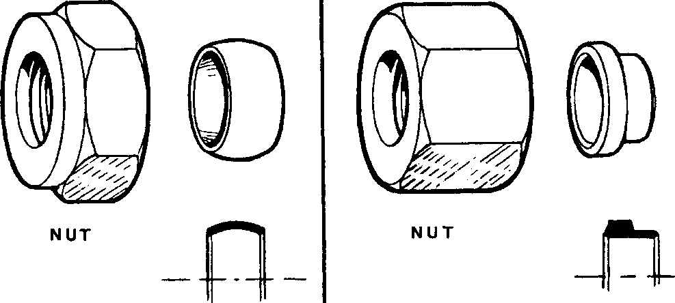Fig EB.l Compression pipe couplings

WADE

BROWNALL

SEALING RING

SEALING RING

SPD00183

Pipes, Unions etc.

1. Carefully examine all pipes for cracking and chafing, especially at bends and clips. Also examine pipes for cracked union nuts and dirt on seatings of nipples. Never strain a pipe when connecting it up, but find out why it will not meet the other part.

NOTE Engines can be fitted with compression couplings manufactured by 'WADE' or 'BROWNALL*. Fig EB.l illustrates nuts and sealing rings of both types. 'WADE' couplings are easily identified by the plain diameter machined on the rear of the nut. The sealing rings are different as are the interior surfaces of the nut and body. For this reason parts cannot be interchanged as sealing would be affected.

1. When fitting NEW 'WADE' type couplings, check that pipe is bedded fully home in the union body and the sealing ring is in contact with the body. Screw the nut finger tight and then tighten TWO FULL TURNS.
2. When fitting NEW 'BROWNALL' type couplings, check that pipe is bedded fully home in the union body, and the sealing ring is in contact with the body. Screw up and tighten the nut until the sealing ring is felt to grip the pipe (this may be checked by gently moving the pipe) and then tighten ONE FULL TURN.
3. When REFITTING either type of coupling, check the sealing ring is in contact with the union, screw up nut finger tight and then tighten a further 1/4 to 1/2 turn. If this does not make a seal, further tightening will have no effect; the joint must be dismantled and a new sealing ring fitted. OVERTIGHTENING THE NUT CAN DAMAGE THE PIPE.
4. Unless otherwise stated, apply ’LOCTITE’ 225 to the threads of all plugs, stud couplings, pipe couplings and other fittings which are required to seal against liquid leakage. THIS INSTRUCTION DOES NOT APPLY TO PIPING BETWEEN THE FUEL INJECTION PUMP AND INJECTOR.

Cleanliness

1. Always observe strict cleanliness when rebuilding and flush all oilways, pipes, etc, clear of sludge and dirty oil. Machined surfaces should be oiled to provide initial lubrication and protection against corrosion.
2. DO NOT use cotton waste or dirty rag for wiping parts before assembly, since loose strands may become detached and find their way into oilways and between moving parts. For this same reason DO NOT USE WOOL BASED CLOTHS FOR CLEANING.
3. Filings and scrapings must be prevented from entering oilways or ports. Rough or ragged edges should be removed from all moving parts, oilways, ports, etc.
4. New parts should be kept in their protective coating until required.

Schedule of Clearances and Wear Limits

1. When assembling new parts, ensure the correct fit is obtained. A Schedule of Clearances and Wear Limits is provided (Section CD) for all engine parts with a close-running fit. Maximum permissible clearances are quoted, which, when exceeded, call for the renewal of one or both parts. Reference to the Schedule will indicate which of the parts could best be renewed in order to bring the working clearance to a figure which will allow the engine to operate to the next overhaul.

Engine Servicing

1. Engine systems such as the cooling, lubrication and fuel systems, engine protection equipment, etc., should be studied so that due consideration can be given to these items when servicing the engine. A full description of these systems, together with operating notes, is included in the appropriate sections.

Special Tools

1. Throughout this Manual special tools and equipment are referred to, illustrated where considered necessary, and listed at the end of each section. Standard hand tools such as spanners, etc., are not normally mentioned or illustrated.

'Vee' Belts

1. 'Vee' belts must be kept at the correct tension. Belts that are too tight will overload bearings and those that are too loose will slip and fail. A belt in correct tension can be moved an amount equal to its own thickness for each 48in (1220mm) of unsupported length.
2. Belts should be kept clean and free from grit and oil. To clean belts, wipe with a dry cloth; DO NOT use a belt dressing.
3. Never replace belts in a multi-belt drive singly. Always fit a complete, matched set.
4. Pulley grooves must be correctly aligned and free from oil and grease before fitting belts.

CHAPTER 2

CLEANING

NOTE HEALTH AND SAFETY STANDARDS (Chapter 1, Para 1.2) must be observed when using cleaners, degreasants and solvents. All should be used in well ventilated areas.

1. Various proprietary brands of cleaning and degreasing solutions are marketed for use with ferrous and non-ferrous materials and, if required, our Service Department will supply details.
2. The following notes are intended to serve as a GUIDE to cleaning operations, but it is realised that it will not always be possible to do as suggested.
3. An effective method of cleaning ferrous parts is by total immersion in a heated caustic soda bath (where such facilities are available), followed by a thorough washing in hot water.
4. Non-ferrous parts can be cleaned by total immersion in TRICHLOROETHANE eg, 'GENKLENE', followed by thorough washing in hot water. On no account should non-ferrous parts be allowed to come in contact with caustic soda solutions.
5. If either of the above methods cannot be used, the parts should be washed in clean, UNLEADED PETROL or KEROSENE. A separate clean bath should be used for final washing before assembly.
6. Before cleaning, all thick deposits of carbon or sediment should be removed by hand scraping, care being taken to avoid scratching machined surfaces.
7. Oil holes should be pricked through with wire, thoroughly washed, and then blown through with compressed air to ensure freedom from obstruction.
8. After cleaning, all bright parts should be smeared with oil or grease to prevent rusting, refer to Paras 1.5 to 1.9.

NOTE This does not apply to fuel injection equipment.

AEROQUIP FLEXIBLE HOSE CONNECTIONS

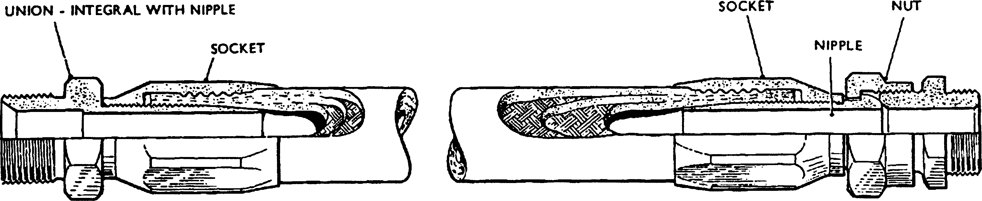

MALE FITTING FEMALE FITTING

INNER TUBE*.- OIL RESISTING SEAMLESS SYNTHETIC RUBBER COMPOUND. REINFORCEMENT- SINGLE WIRE BRAID AND SINGLE COTTON BRAID. OUTER COVER!- SYNTHETIC RUBBER.

SPD00184

Fig EB.2 Typical assembly of Type 2651 hose and fittings

1. The following instructions are for the assembly of Type 2651 AEROQUIP flexible hose connections. Aeroquip hose fittings are detachable and re-usable, and therefore instant replacements can be made to flexible pipelines providing a supply of new Aeroquip hose of the correct bore and type is available.
2. Female hose fittings consist of three parts (Fig EB.2), a socket, a nipple and a nut. A coarse left hand thread in the socket provides for rapidly screwing in the hose. A recess at the end of this coarse thread facilitates entry of the nipple which is screwed into the socket by means of a fine thread, to firmly grip the hose. The male fitting has two parts only, the socket and nipple. The male thread is part of the nipple.

Cutting Hose to Required Length

1. To prevent early failure in service, these instructions must be followed when making up replacement assemblies:-
2. For straight flexible lines, the hose must be cut long enough to provide slack when in position. This will allow for any end-wise tension under operating conditions or changes in length which may occur when internal pressure is applied.
3. Make sure the hose is not twisted during fitting by checking the stripe marked on outside. Twisted hose may cause failure or loosening of end fittings.
4. Avoid sharp bends which would cause strain or collapse. If space does not permit generous bends, use Aeroquip elbows for changes in direction. The minimum bend inside radii for Type 2651 Rubber covered single wire braid hoses are shown in TABLE EB.l.

Assembly Tools

* 1. Tools of the correct size and type are required when assembling fittings to their hose. The tool required and the size and type of fitting are shown in TABLE EB.2.

|  |  |  |  |  |  |
| --- | --- | --- | --- | --- | --- |
| MAKER’S PART No | HOSE  ID  (in) | HOSE  OD  (in) | MIN BEND RADII (in) | FITTINGS THREAD SIZE BSP (in) | WORKING  PRESSURE  (lb/in2) |
| 2651-5 | v4 | 37/64 | 33/8 | y4 | 3000 |
| 2651-6 | 5/l6 | 43/64 | 4 | 3/8 | 2250 |
| 2651-8 | 13/32 | 49/64 | 45/s | y2 | 2200 |
| 2651-10 | v2 | 59/64 | 5’/2 | 5/8 | 1750 |
| 2651-12 | 5/8 | l5/64 | 6V2 | 3/4 | 1500 |
| 2651-16 | 7/8 | l15/64 | 73/s | 1 | 800 |
| 2651-20 | lVs | y/2 | 9 | iy4 | 600 |
| 2651-24 | l3/8 | l3/4 | ioy2 | iy2 | 500 |
| 2651-32 | l13/l6 | 27/32 | 13V4 | 2 | 350 |
| 2651-40 | 23/8 | 27/s | 24 | 2'/2 | 350 |
| 2651-48 | 3 | 319/32 | 33 | 3 | 200 |

TABLE EB.l - HOSES, TYPES, SIZES AND FITTINGS

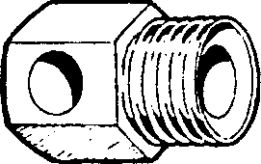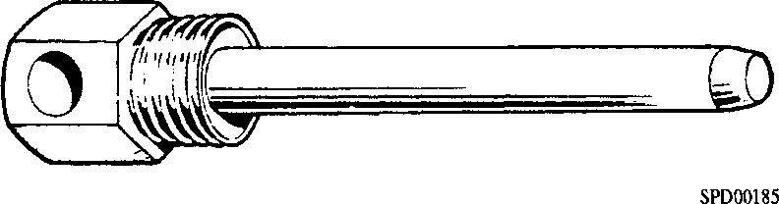

TYPE: AT 100 Fig EB.3 Assembly tools

TYPE: ATI002

TABLE EB.2 - ASSEMBLY TOOLS

|  |  |  |  |  |  |
| --- | --- | --- | --- | --- | --- |
| FEMALE FITTING | | | MALE FITTING | | |
| PART | THREAD | TOOL | PART | THREAD | TOOL |
| No. | SIZE | PART | No. | SIZE | PART |
|  | BSP (in) | No. |  | BSP (in) | No. |
| E202-5 | y4 | AT 100-5 | E212-5 | y4 | AT 100-5 |
| E202-6 | 3/8 | AT 100-6 | E212-6 | 3/8 | AT100-6 |
| E202-8 | y2 | AT 100-8 | E212-8 | y2 | AT 100-8 |
| E202-10 | 5/8 | AT100-10 | E212-10 | 5/8 | AT100-10 |
| E202-12 | 3/4 | AT100-12 | E212-12 | 3/4 | AT100-12 |
| E202-16 | 1 | AT1002-16 | E212-16 | 1 | NOT REQD |
| E202-20 | 1V4 | AT1002-20 | E212-20 | 13/4 | NOT REQD |
| E202-24 | iy2 | AT 1002-24 | E212-24 | iy2 | NOT REQD |
| E202-32 | 2 | AT 1002-32 | E212-32 | 2 | NOT REQD |
| E212-40 | 2 y2 ) | NOT REQD., | E212-40 | 2 y2 | NOT REQD |
| E202-48 | 3 ) | Assemble as elbow connection | E212-48 | 3 | NOT REQD |

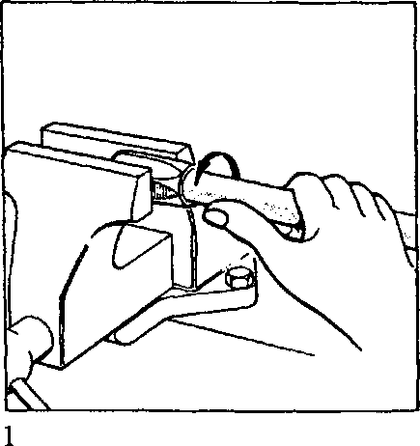Fig EB.4 Assembly of female fittings to hose

FEMALE FITTINGS

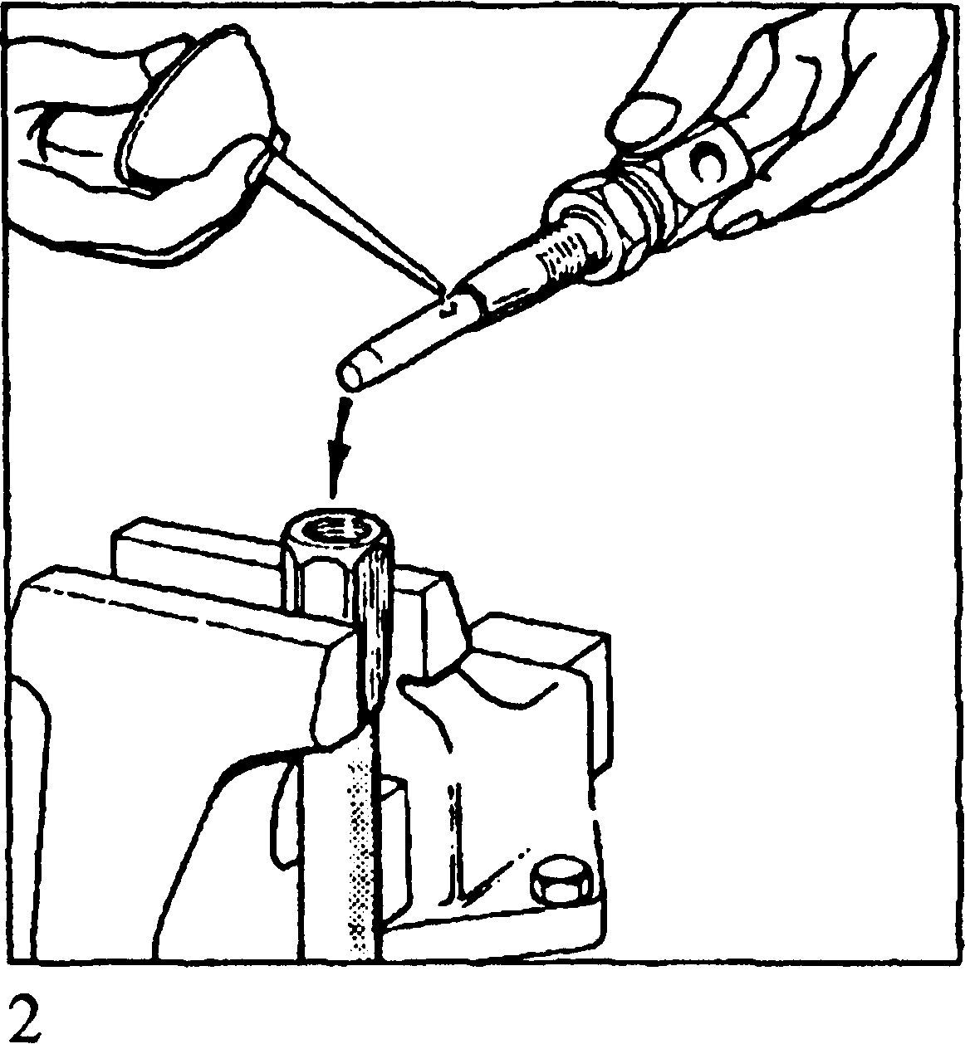

FEMALE FITTING

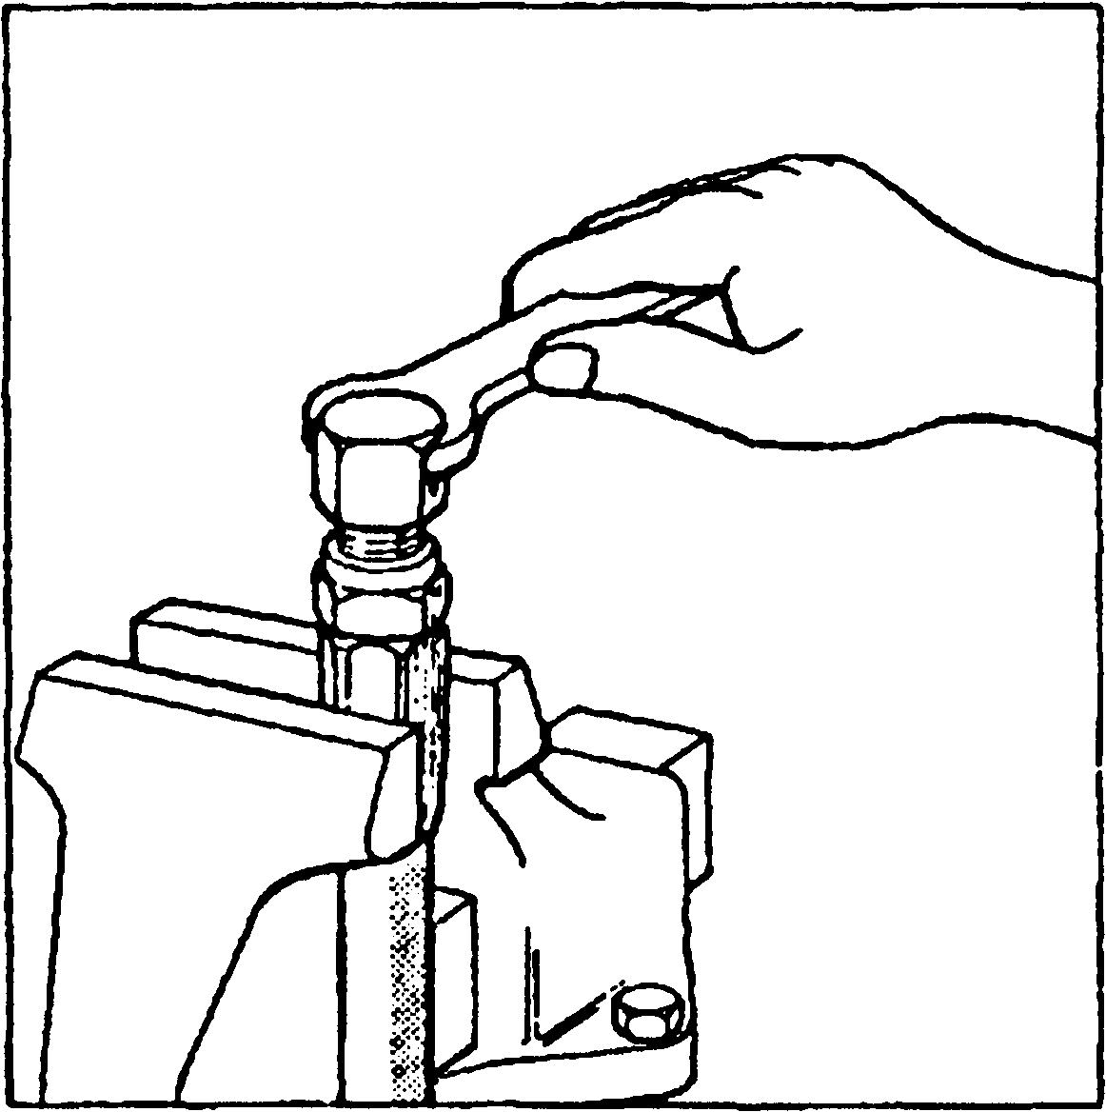

3

SPD00186

Assembly

1. Cut hose to length with fine tooth hacksaw. Holding socket fitting in vice, screw hose anti-clockwise into socket until hose bottoms. Unscrew a quarter turn.
2. Insert nipple into nut, fit to assembly tool and locknut to tool. Lubricate the nipple thread, assembly tool mandrel (if appropriate) and the hose bore with oil SAE 140 (or grease for fittings E202-16 and over).
3. Screw nipple into socket and hose using a spanner on the assembly tool. Leave 1/32 in to 1/16 in (1 to 2mm) clearance between the nut and socket so that the nut will turn when the assembly tool is removed.

Dismantling

* 1. Reverse the order of assembly.

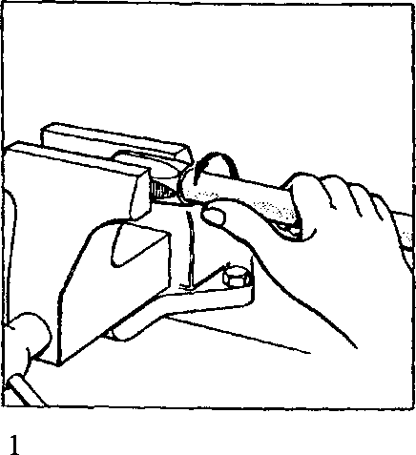MALE FITTINGS

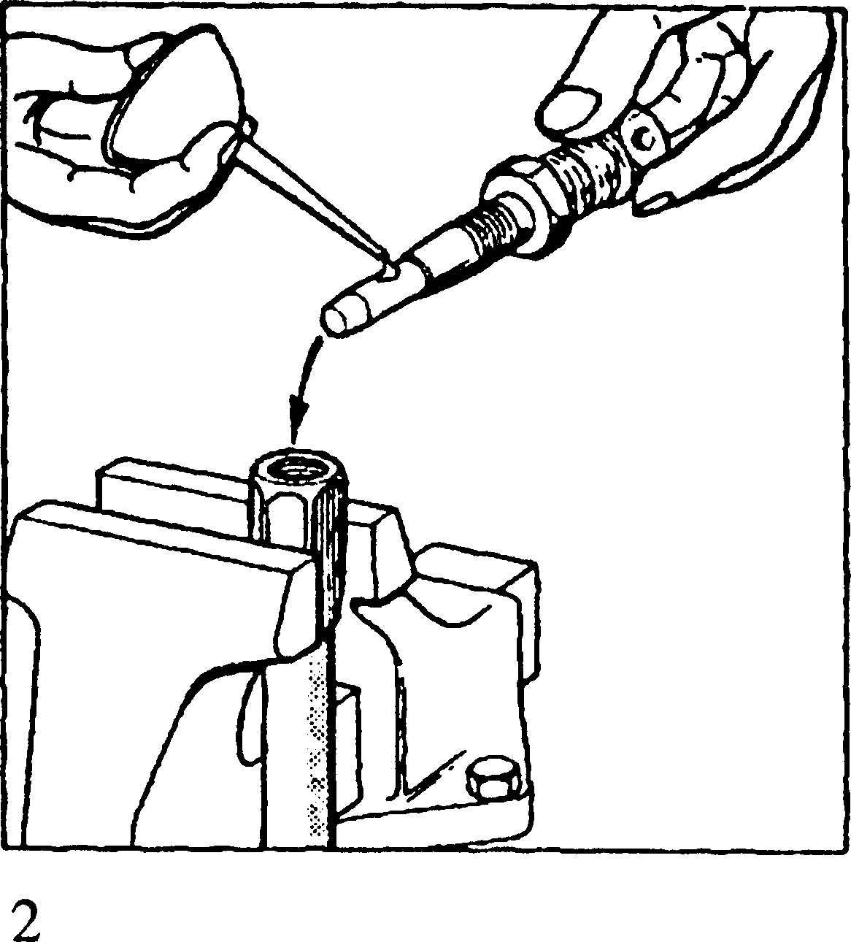

MALE FITTING

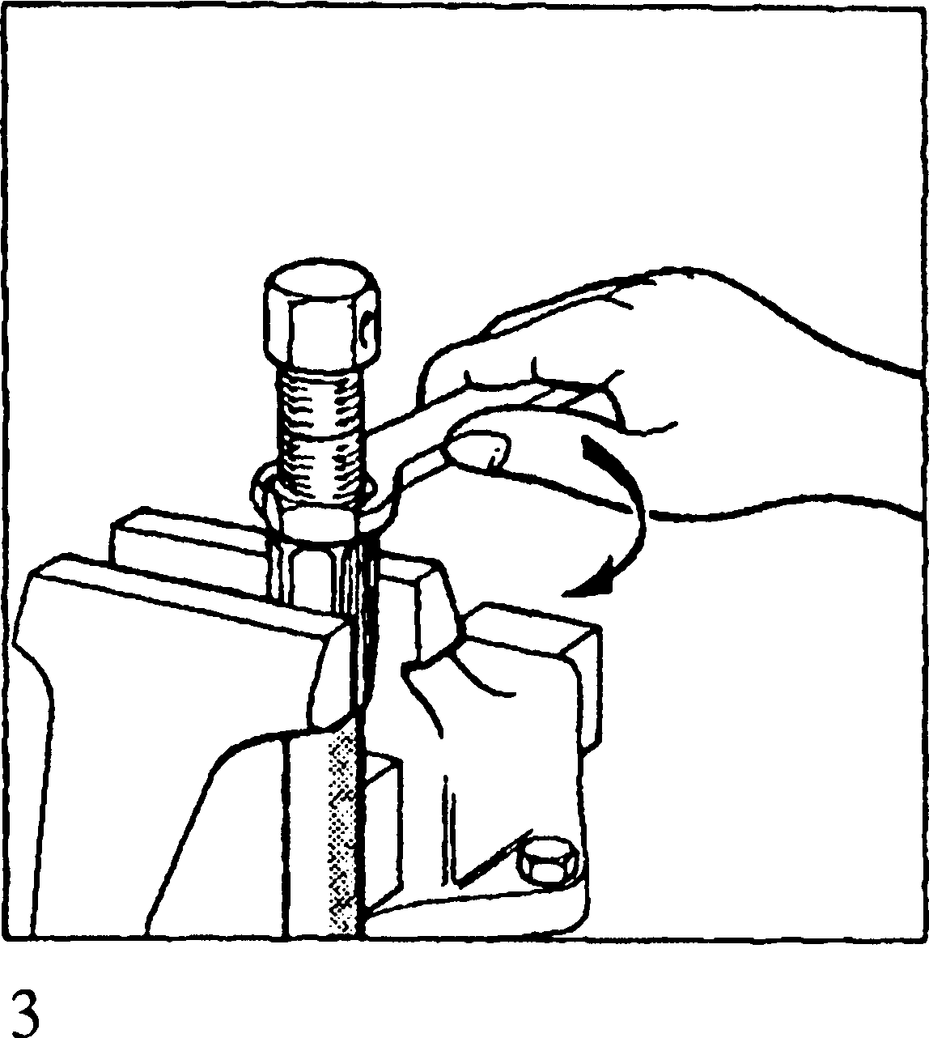

SPD00187

Fig EB.5 Assembly of male fittings to hose

Assembly

1. Cut hose to length with fine tooth hacksaw. Holding socket fitting in vice, screw in hose anti-clockwise until hose bottoms. Unscrew a quarter turn.
2. Place nipple on assembly tool (if appropriate). Lubricate the nipple threads, assembly tool mandrel and hose bore with oil SAE 140 (or grease for fittings E212-16 and over).
3. Screw nipple into socket and hose using a spanner on the hexagon of the fitting. Tighten the nipple until snug against socket.

Dismantling

* 1. Reverse the order of assembly.

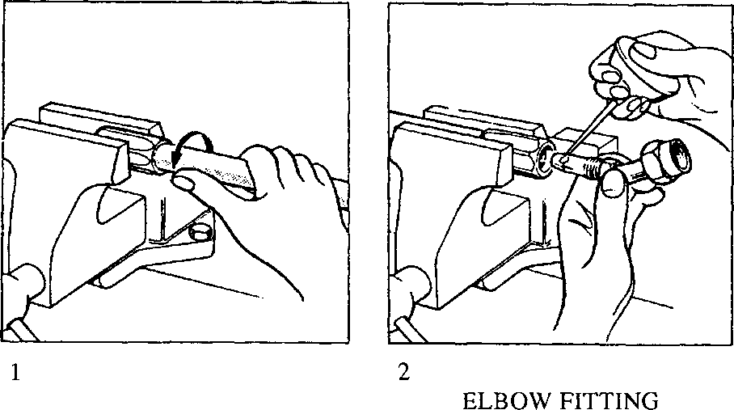ELBOW FITTINGS

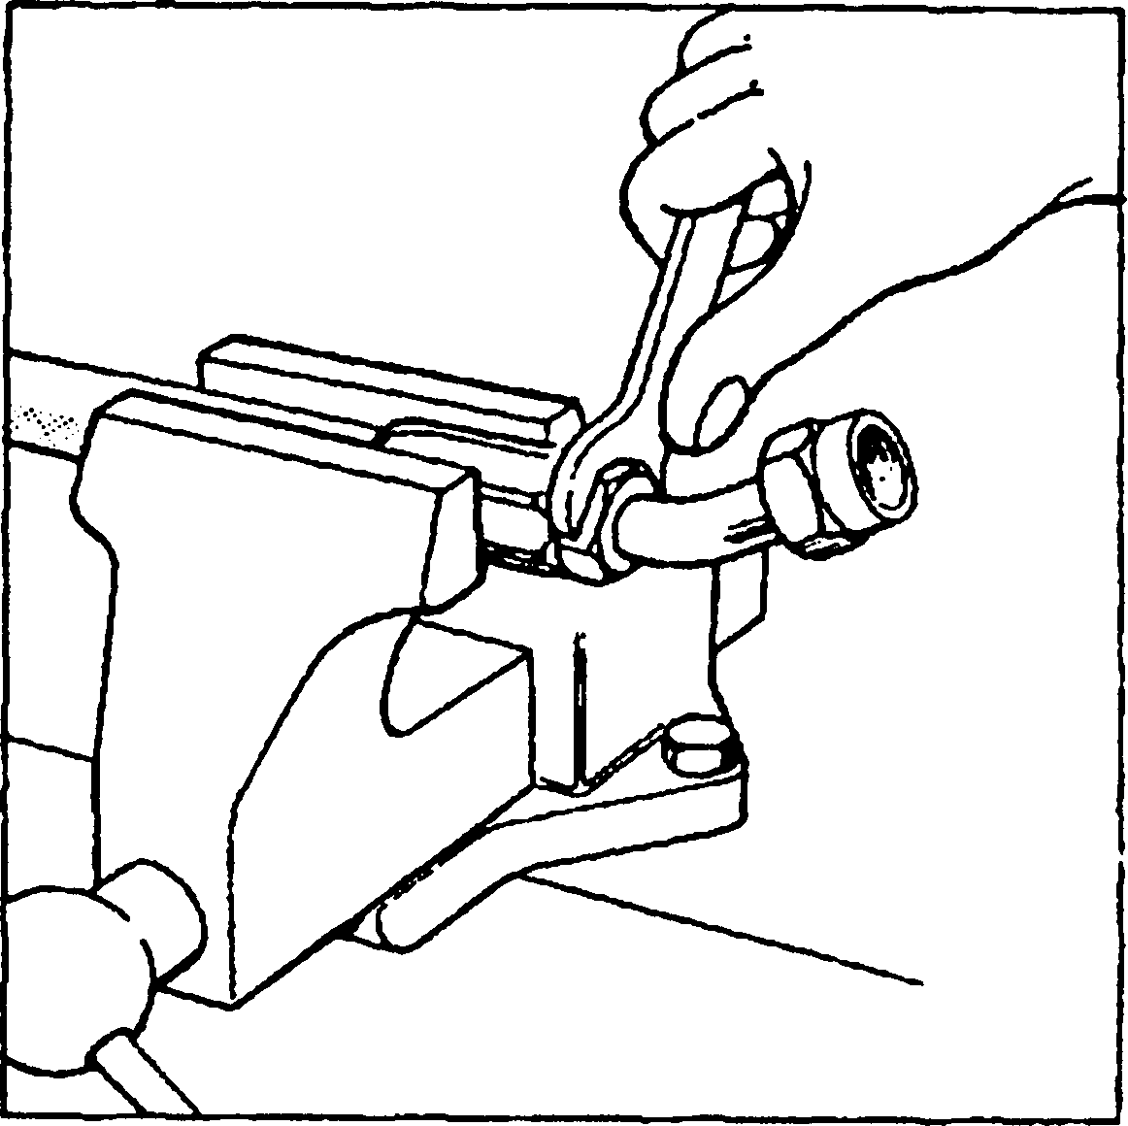

3

SPD00188

Fig EB.6 Assembly of elbow fittings to hose

Assembly

1. Cut hose to length with fine tooth hacksaw. Holding socket fitting in vice, screw hose anti-clockwise into socket until hose bottoms. Unscrew a quarter turn.
2. Lubricate nipple assembly, threads and hose bore using oil SAE 140 (or grease for fittings E204-16 upwards or E208-16 upwards).
3. Screw nipple assembly into socket and hose using a spanner on the hexagon. Tighten nipple assembly until snug against socket. To obtain desired angular position, back off nipple accordingly.

Dismantling

* 1. Reverse the order of assembly.

'LOCTITE' LOCKING AND SEALING COMPOUNDS

WARNING 'LOCTITE' MUST NOT BE USED IN CONJUNCTION WITH EITHER LIQUID OR GASEOUS OXYGEN.

TABLE 1 - TYPES OF 'LOCTITE'

|  |  |  |
| --- | --- | --- |
| ’LOCTITE’ GRADE | | PURPOSE |
| 221 | SCREWLOCK | Mild strength, locking and sealing screws, nuts and bolts |
| 225 | PIPESEAL | Sealing and locking large diameter pipe threads |
| 242 | NUTLOCK | Multi-purpose locking and sealing of threaded fasteners |
| 270 | STUDLOCK | Locking studs and other highly stressed threaded fasteners |
| 275 | PLASTIC GASKET | Locking large diameter parts, sealing flanges and flat surfaces |
| 504 | SUPERFAST GASKET ELIMINATOR | Sealing air duct flanges, pump flanges and gearbox flanges |
| 542 | HYDRAULIC SEAL | Sealing hydraulic, pneumatic and fine thread fittings |
| 640 | RETAINING  COMPOUND | Slow curing requires 48 hours to reach full strength. Needs careful use of solvents before use. Use of Activator 'N' will reduce curing time to approximately 24 hours |
| 648 | RETAINING  COMPOUND | As for 640 where no activator or heat cure can be used |
| IS  415 | CYANOACRYLATE  ADHESIVE | Contact adhesive for nameplates and instruction plates |
| RTV3 SEALANT SILICONE | | PERMANENT fitting of rubber to metal |
| 16113 FLEXIBLE GASKET | | Sealing large diameter parts, flanges and flat surfaces. |

1. 'LOCTITE' is used for locking and sealing in the assembly of PAXMAN engines. 'LOCTITE’ is an anaerobic compound, ie., remains liquid while in contact with air but hardens automatically when between closely fitting metal parts. This self­hardening property gives the products the ability to lock, retain or seal metal parts. The following notes describe the products, the selection of the correct grade and the method of application.
2. ’LOCTITE' may be used with all metals, natural rubber,ceramics and most plastics except; Vinyl, Cellulosics,Styrene, Methacrylates and PVC.
3. When cured the products should not be subjected to temperatures exceeding 150°C.

Method of Application

1. All surfaces to be treated with 'LOCTITE' must be free from oil, grease or detergent residues. Suitable degreasants are 'LOCTITE' SAFETY SOLVENT or TRICHLOROETHANE 'GENKLENE'. Apply solvent generously to surface to be degreased and remove as much solvent as possible whilst still wet to remove residue hard spots Use a clean paper towel, an oily one will only introduce further contamination. Make a final solvent application, if possible in a vertical plane, and allow surfaces to dry naturally. In some instances it may be necessary to apply a Primer; when this is the case it is mentioned in the text.

TABLE 2 - PHYSICAL PROPERTIES

|  |  |  |  |
| --- | --- | --- | --- |
| GRADE | COLOUR | CURE TIME | |
| HANDLING  STRENGTH | ULTIMATE  STRENGTH |
| 221 | Purple | 15 minutes | 3 hours |
| 225 | Brown | 15 minutes | 3 hours |
| 242 | Blue | 15 minutes | 3 hours |
| 270 | Green | 15 minutes | 3 hours |
| 275 | Green | 15 minutes | 3 hours |
| 504 | Bright Orange | NOT APPLICABLE | NOT APPLICABLE |
| 542 | Brown | 15 minutes | 3 hours |
| 640 | Clear | 15 minutes | 3 hours |
| 648 | Green Fluorescent | 2 hours | 6 hours |
| RTV.3 | Translucent | NOT APPLICABLE | NOT APPLICABLE |
| IS 415 | Colourless | 1 minute | 3 hours |

WARNING UNLESS CONTACT AREA IS VERY SMALL, COMPONENTS WHICH ARE TO BE BE DISMANTLED SHOULD NOT BE SEALED WITH GRADE 640 OR 648.

1. The method of applying the different grades of 'LOCTITE' is as follows:-

4.5.1 Grades 221, 242, 270 275 and 16113. Apply straight from dispenser nozzle supplied with each bottle to nut, screw or stud. 'LOCTITE' need only be applied to one part. For blind holes, apply to a point two-thirds of the way down the hole, otherwise the 'LOCTITE' may be forced out when the screw is inserted. Only sufficient 'LOCTITE' to fill the gap between threads is required.

1. Grades 225, 504 and 542. These grades are supplied in bottles with a ribbon- type dispenser nozzle permitting application straight from the bottle to the threads before assembly.
2. Grades 640 and 648. Apply straight from dispenser bottle to either component, sparingly but evenly

Health and Safety Precautions

1. It is essential, whilst using the 'LOCTITE' products detailed above, that all precautions regarding safe application or removal of the products be observed. Particulars of the precautions necessary whilst handling adhesives, primers, and solvents are obtainable, either from the manufacturer or from PAXMAN DIESELS LTD.

LIQUID NITROGEN - SAFETY PRECAUTIONS

WARNING DO NOT USE LIQUID OXYGEN OR LIQUID AIR FOR FREEZING. MOST PARTS WILL HAVE TRACES OF LUBRICATING OIL OR PRESERVATIVE OIL REMAINING ON THEM. A MIXTURE OF OIL AND EITHER LIQUID OXYGEN OR LIQUID AIR IS LIABLE TO CAUSE AN EXPLOSION.

1. Liquid Nitrogen is used to freeze certain parts where an interference fit is required. This reduces the outer diameter and assists in fitting.
2. The temperature of liquid nitrogen is -196°C and the safety precautions listed below MUST BE OBSERVED.
3. Suitable protective clothing including insulating gloves and face visor must be worn.
4. Ready to use liquid should be stored in a sealed, double wall vacuum flask type container.
5. The container used for freezing parts should also be of the double wall type and only sufficient liquid should be used to cover the part.
6. When a part is placed in the liquid, the liquid will boil and will continue to do so until the part cools to the temperature of the liquid.
7. Tongs or a hook tool must be used to place a part in the liquid and also for removal.
8. To avoid splashing, parts must not be dropped into the liquid.
9. Reduction in temperature will make parts brittle and they will remain brittle until they warm back up to room temperature. Care must be taken in handling while in a brittle condition.

EXHAUST THERMOCOUPLE CABLE

1. Engine exhaust thermocouple cables comprise two inner conductors in an armoured outer casing. To reduce the chance of inner conductor breakage, excess cable should be coiled close to the thermocouple probe before securing to a support.

CHAPTER 7

VITON 'O' RINGS

WARNING VITON 'O' RING SEALS WILL DECOMPOSE IF HEATED TO TEMPERATURES IN EXCESS OF 200°C (400°F) AND FORM HYDROGEN FLUORIDE GAS. THIS GAS WILL REACT WITH ANY MOISTURE (EG. ATMOSPHERIC) TO FORM HYDRO­FLUORIC ACID LIQUID. THIS ACID IS HIGHLY CORROSIVE AND CONTACT WITH THE SKIN MUST BE AVOIDED. FOR INSTRUCTIONS ON NEUTRALISING AND HANDLING SEE SECTION EB.

1. Viton 'O' ring seals can to be found in the following places on Paxman Valenta engines:-
2. Between exhaust manifolds and turbochargers
3. In the air induction manifolds and piping
4. In the air intake shutdown valve
5. In the drive-end cover (crankshaft 'Vee' seal)
6. Cylinder liner 'O' rings
7. Certain transfer ferrule joints (Those prefixed YK only)
8. Should it be suspected that that Viton 'O' rings have been subjected to abnormally high temperatures eg., after test rig or engine overheating, fires or high temperature testing, PRECAUTIONS MUST BE TAKEN TO AVOID ANY POSSIBILITY OF SKIN CONTACT UNTIL THE SEALS HAVE BEEN INSPECTED. If decomposition has occurred, seals will appear as a charred black mass.
9. Due to the highly reactive nature of HYDROFLUORIC ACID, it is likely that it will attack surrounding metal components. If decomposed Viton 'O' rings are found during engine dismantling, it must be reported to the person in charge of the installation to enable the correct remedial action to be taken.
10. The following procedures must be adopted when neutralising, handling or disposing of suspect or decomposed Viton 'O' rings:-
11. Do not touch blackened or charred seals or equipment with any unprotected parts of the body. Use PVC (polyvinylchloride) or Neoprene protective gloves to handle parts containing, or contaminated by decomposed fluoroelastomers.
12. Allow all burnt or decomposed fluoroelastomer materials to cool down before inspection, investigation, tear-down or removal.
13. Contaminated parts, tools, materials or areas should be neutralised by washing in a saturated solution of calcium hydroxide (limewater), followed by flushing with plain water.
14. Contaminated parts, residues, materials and clothing, including protective clothing and gloves should be disposed of by approved contractor to landfill or by incineration according to national and local regulations. Original seals, gaskets and 'O’ rings along with contaminated material must not be burned locally.
15. In the event of skin contact with HYDROFLUORIC ACID treat as follows:-
16. Remove contaminated clothing immediately.
17. Irrigate affected areas of skin with copious amounts of cold water or preferably a saturated solution of calcium hydroxide (limewater) for at least 15 minutes.
18. Seek skilled medical advice urgently.
19. See The Society of Motor Traders and Manufacturers Limited pamphlet on the guidance of use of fluoroelastomers overleaf.

SMMT GUIDANCE ON FLUOROELASTOMERS

This guidance note has been prepared by the SMMT Toxic and Hazardous Materials Working Group. It is concerned with the hazards created by such materials when they become subject to high temperature decomposition, such as in a fire. While the concern is focused on fluoroelastomers, all polymeric materials are liable to produce hazardous fumes and toxic decomposition products when heated. It is recommended that any such materials which have or may have been subject to extremes of temperature should be treated with caution; skin contact must be avoided. See recommended cautionary note for vehicle operating manuals (att 2).

FLUOROELASTOMER - HAZARDS AND PRECAUTIONS

1. Introduction

When used within designed operating conditions fluoroelastomer and other fluorine- containing polymers are safe and do not present hazards to health.

In high-temperature rig testing and in fire conditions involving temperatures greater than 315°C they will decompose and can be potentially hazardous. Some decomposition may occur at temperatures above 200°C. Fluoroelastomer materials will show physical signs of decomposition under such conditions in the form of charring or black sticky masses.

1. What are they?

Fluoroelastomers are synthetic rubber-like materials which contain fluorine. They are commonly used in motor industry manufacturing and test equipment and in motor industry products. Applications include test rigs, fuel systems, oil seals, wiring and cabling, bearing surfaces, engines, axles and transmissions. They are commonly present as seals, gaskets, diaphragms, hoses and 'O' rings.

Trade names for these materials include, but are not limited to, 'Viton', 'Fluorel', 'Fluorabon', 'Technoflon', 'kel-F', 'Aflas' and 'Kairez'. See fluoroelastomer manufacturers' press release (att 3).

These materials do not include natural, SBR or other synthetic rubbers such as nitrile rubber.

1. Hazards

Highly toxic and corrosive decomposition products, including hydrogen fluoride, carbonyl fluoride, fluorinated olefins and carbon monoxide can be generated and be present in fumes from fires or high temperature testing.

In the presence of any water or humidity (including atmospheric moisture) hydrogen fluoride can dissolve to form extremely corrosive liquid hydrofluoric acid which may collect in pockets or spaces. Skin contact with this liquid or decomposition residues can cause painful and penetrating burns. Permanent irreversible skin and tissue damage can occur.

1. Precautions
   1. Test rig. vehicle engine and storage area fires

o mark stores and stock areas with a sign that will remain legible during a fire.

o assume unless you know otherwise, that seals, gaskets and 'O' rings are

fluoroelastomers.

o inform fire-fighters of the presence of fluoroelastomers and toxic and

corrosive fume hazards when they arrive for fire fighting.

o all personnel not wearing breathing apparatus must leave the immediate area

of a fire.

o fire fighters must wear face masks, self-contained breathing apparatus and full

protective clothing.

* 1. After fires or high-temperature testing

o do not touch blackened or charred seals or equipment.

o allow all burnt or decomposed fluoroelastomer materials to cool down before

inspection, investigation, tear-down or removal.

o contaminated parts, tools, materials or areas should be neutralised by washing

in limewater (calcium hydroxide solution), followed by flushing with plain water.

o use PVC (polyvinylchloride) or Neoprene protective gloves to handle cool

parts containing decomposed fluoroelastomers.

o contaminated parts, residues, materials and clothing, including protective

clothing and gloves should be disposed of by approved contractor to landfill or by incineration according to national and local regulations. Original seals, gaskets and 'O' rings along with contaminated material must not be burned locally.

1. Symptom and clinical findings
   1. Inhalation (breathing) - immediate o coughing

o choking

o chills lasting 1-2 hours after exposure

o irritation

* 1. Inhalation (breathing) - delayed 1 to 2 days and more o fever

o cough

o chest tightness

o pulmonary edema (congestion)

o bronchial pneumonia

* 1. Skin

Symptoms may be apparent immediately, soon after contact or there may be considerable delay after exposure. DO NOT assume that there has been no damage from a lack of immediate symptoms; delays of minutes in treatment can have severe consequences:

o dull throbbing ache

o severe and persistent pain

o black discolouration under nails

o severe, persistent and penetrating burns

o skin swelling and redness

o blistering

o sometimes pain without visible change.

1. First Aid
   1. Inhalation

o remove to fresh air and obtain medical supportive treatment immediately.

Treat for pulmonary edema.

* 1. Skin contact

o remove contaminated clothing immediately.

o irrigate affected skin with copious amounts of cold water or limewater

(calcium hydroxide solution) for 15-60 minutes. Obtain medical assistance urgently.

* 1. Eye contact

o wash/irrigate eyes immediately with water followed by normal saline for

30-60 minutes. Obtain immediate medical attention.

SMMT T and HM WG November 1990

FLUOROELASTOMERS

CAUTIONARY NOTE

Recommended text for use in vehicle/operating/workshop manuals.

Fluoroelastomers are synthetic rubbers often used in engines, engine test rigs and other equipment such as 'O' rings and gasket seals. When used within designed operating conditions fluoroelastomers are safe and do not present a hazard to health.

If heated beyond normal operating conditions, for example in a fire, they can break down to give a highly corrosive acid (hydrofluoric acid) - this can cause serious burns on contact with skin. Avoid skin contact with fire damaged rubbers • for further information and advice refer to SMMT guidance (attachment 1).

SMMT T and HM WG November 1990

PRESS RELEASE

1981 FLUOROELASTOMER INCIDENT

Du Pont, Montefluos and 3M, manufacturers of fluoroelastomers, have issued the following statement in connection with an incident that occurred at the National Nuclear Corporation (U.K.) in 1981, which has been the subject of some recent comment.

In this incident, in which an employee sustained an injury while venting test rig components following high temperature tests of seals based on a fluoroelastomer, the manufacturers wish to make it clear that the injury resulted from contact with concentrated acid NOT from contact with the elastomer seal.

The accident occurred at the National Nuclear Corporation during a research exercise involving the deliberate destruction of fluoroelastomer seals in 600 psi (4.15 MPa) carbon dioxide at temperatures up to 400 degrees Centigrade. Design of the test chamber was such that evolved volatiles could be trapped in an annular space between concentric O-rings. When this space was vented to atmosphere after overnight cooling, a small quantity of clear liquid dripped onto the employee's finger.

Although he irrigated the finger with running water, a burn progressively developed, eventually necessitating amputation of part of the finger. Analysis showed that the liquid had a pH value of one and it is understood that it was a hydrofluoric acid formed by dissolution of hydrogen fluoride in water.

Under normal conditions encountered in industrial and automotive seal applications, the use of fluoroelastomers presents no health hazard during installation or maintenance. Over the past 30 years, millions of fluoroelastomer parts have been safely fitted and maintained in the automotive, aerospace and chemical process industries. To the knowledge of Du Pont, Montefluos and 3M, the incident outlined is the only one of its kind recorded in which an injury resulted after a fluoroelastomer was heated above its recommended service temperature. Technical information relevant to the safe use, handling and storage of fluoroelastomers and fluoroelastomer based parts can be obtained from any of the manufacturers making the statement.

NOTE TO THE EDITOR

For "Viton" fluoroelastomer:

1. S. Billett/V. Williams  
   Du Pont de Nemours International S.A.  
   2, ch. du Pavilion

CH-1218 Le Grand-Saconnex/Geneva

Tel: (022) 717 51 11  
Telex: 415 777 DUP CH  
Fax: (022)717 51 09

For "Tecnoflon" fluoroelastomer:  
M.G. Assante/Miss Moretti  
Montefluos S.p.a.

Via Principe Eugenio 1/5  
1-20155 Milano

Tel: (02) 6270 3440/(02) 6270 3428  
Telex: 310 679 MONTED I  
Fax: (02) 6270 3788

For "Fluorel" fluoroelastomer:  
M.K. Bradfield/D. Cook  
3M United Kingdom PLC  
3M House  
P.O. Box 1

UK-Bracknell/Berkshire

Tel: (0344) 58713/(0344) 58885  
Telex: 849 371 MMMUKA G  
Fax:(0344) 58278  
DSB30.89/cl 1989-lG-Go